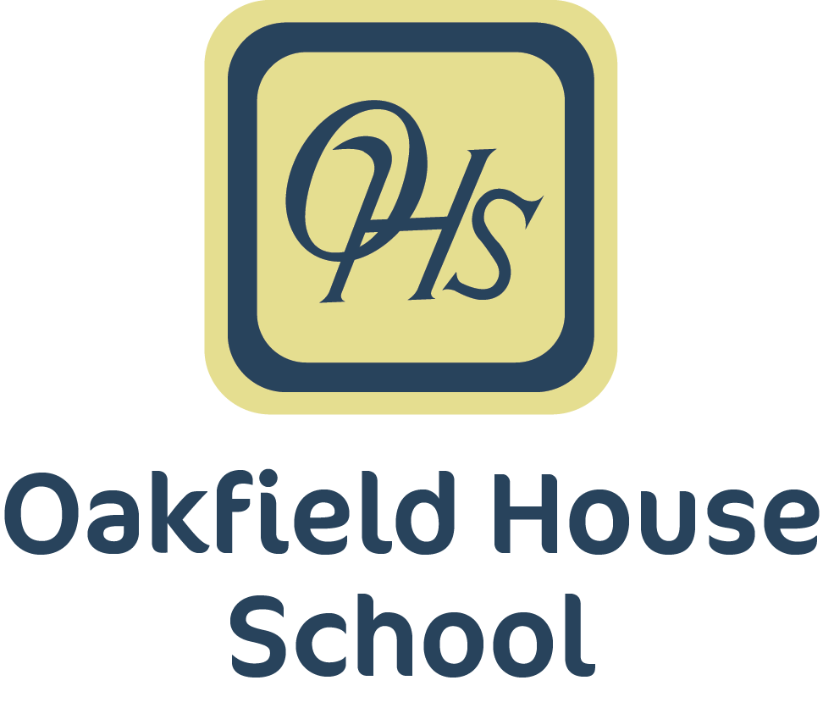

Admissions
Policy

Policy Document
(2023-2024)

Updated: | December 2023
Review date: | December 2024
Signed by:

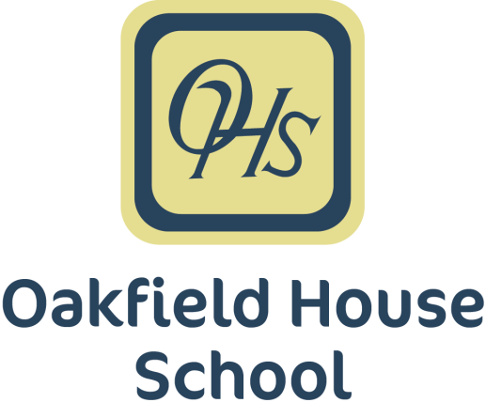

Admissions Policy
Pupil Numbers

Oakfield House School is registered with the Department of Education and provides places for up to 42 boys and girls aged 5 to 12. There are currently seven class groups. Class groups may be combined to form a more viable teaching and learning group.

Admission Criteria

Pupils will be aged between 5 and 12 years.
All pupils will have an Education, Health Care Plan (EHCP).
The plan will specify that the pupil has social, emotional and mental health issues (SEMH)/ASD difficulties and behaviours, which may be deemed challenging or inappropriate in other school settings.
Pupils will normally have been assessed as being within the low to average ability range.
Pupils may have specific or generalised learning difficulties.
There might be exceptional circumstances in which a pupil is admitted for a formal assessment by the LA.

Admissions Process

All pupils admitted to Oakfield House School will have been initially referred by their Local Authority (LA). If, after reviewing the information provided, the school believes that the pupil meets the admission criteria, arrangements will be made with the LA for the parents/carers and pupil to visit the school. The interview will include a tour of the school and a meeting at which the school policies and curriculum are discussed. Visitors will have the opportunity to ask any questions they may have. This interview will be supported by a visit to the prospective pupil’s home by a member of the Senior Leadership Team where any additional matters can be discussed within the pupil’s home environment.

If, following these visits, all concerned are agreed that the pupil’s needs can be met at the school and that the pupil and parent/carers are committed to the placement, arrangement will be made for admission.

The LA will:

- Confirm acceptance of the offer of placement.
- Attend Annual Review Meetings.

The school will provide each pupil:

- A maximum of two school jumpers.
- Grey trousers and white polo t-shirt should be provided by parents/carers, and parents/carers may also purchase additional jumpers from the school if they wish.
- A drink, toast or/and cereal on arrival at school each morning.
- A choice of two school meals at lunch time and a desert. On days when pupils are on an educational visit they are provided with a packed lunch. If a pupil has specific dietary needs, these will be catered for.

The school will provide each parent/carer:

- Details of Oakfield House School and Options Autism information.
- A School Prospectus.

