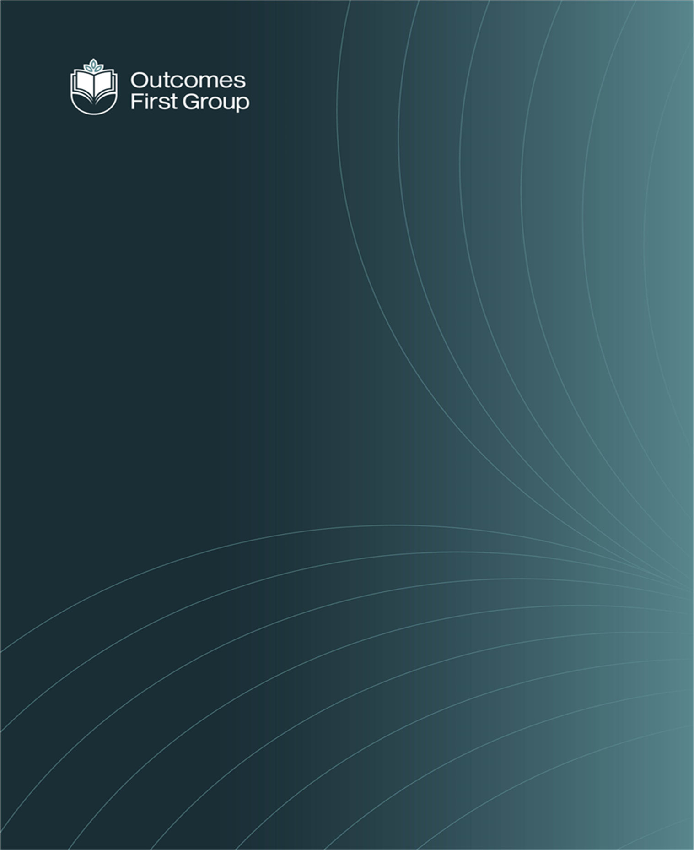
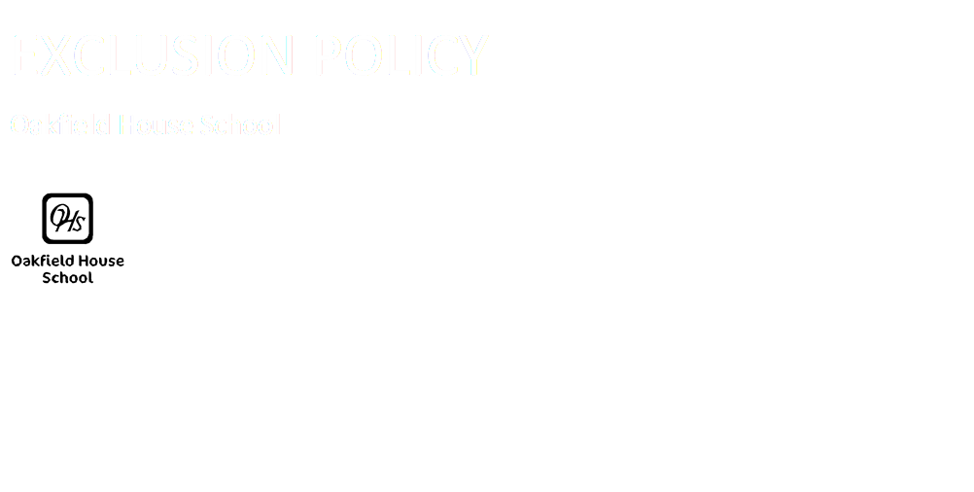

CURRICULUM POLICY

Oakfield House School
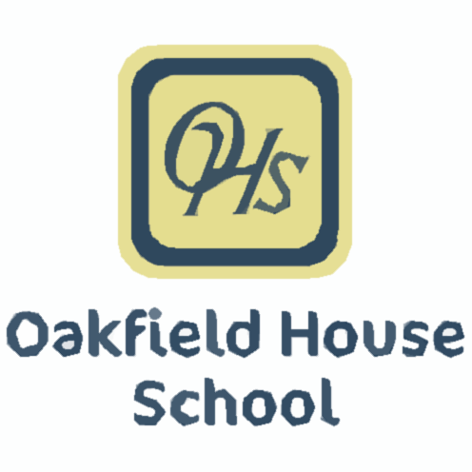

Introduction

Oakfield House School is a Day School for boys and girls aged 5 to12 who have needs arising from Autistic Spectrum Conditions, Learning Difficulties and Social, Emotional and Mental Health difficulties. Pupils attend our school from a wide range of local authorities and they all have an Educational Health and Care Plan. Before joining our school, as a result of their behaviour, communication or emotional difficulties, many pupils have been unable to access an educational curriculum effectively.

At our School we believe that the word ‘curriculum’ should be interpreted in its widest meaning. It is every planned learning experience the pupils have as a member of the school, both learnt formally within a lesson or informally outside the classroom throughout the whole school day. It is all the planned activities that we organise in order to promote learning, personal growth and development. Teachers and support staff structure these experiences to ensure that they have the most positive effect on the attainment, progress and personal development of all pupils; delivering a broad curriculum that includes a range of linguistic, mathematical, scientific, technological, human, social, physical, aesthetic and creative aspects appropriate to their age, ability and stage of development.

Curriculum Aims
· Help young people to develop positive feelings of self-worth and confidence.
· Provide a broad and balanced curriculum, including a focus on independence skills that is inclusive and accessible to all
· Help prepare children and young people for the next stages in their life
· Deliver activities that provide suitable learning challenges, giving every young person the opportunity to experience success and achieve as much as possible.
· Devise individual approaches and interventions, in response to the curriculum, to match young people’s diverse learning needs, interests and strengths.
· Teach young people to have an awareness of their own spiritual development, understand right from wrong and have an appreciation of British Values.
· Provide a curriculum that is free from partisan political view

Children can access the curriculum at different levels, according to their individual need. They may experience barriers to learning, related to: cognition and learning including memory, communication and interaction, language and concept development, flexibility of thought, sensory processing, social awareness and behaviours arising from their individual needs.

Approaches used to plan and deliver the curriculum are created to meet the needs of the individual child. For some this may include the use of subject focussed approaches, and for others it is more appropriate to base these approaches on Personalised Learning Intentions.
Our planning is driven by the young people’s needs and interests, whilst also being informed by Development Matters, National Curriculum, and other approaches to planning learning such as our Personalised learning intentions, which are linked to a young person’s individual EHCP outcomes.

The Senior Leadership Team are responsible for monitoring the planning and delivery of the curriculum using a quality assurance framework. This monitoring is organised into an annual timetable of deep dives, alongside short reviews and audits.

As part of the admissions process, and after a place has been confirmed, a range of data and information is forwarded to education staff prior to the young person arriving. This information will include education, social and medical history, attendance, safeguarding issues and involvement of other agencies. Staff will also informally assess the child, by making visits to the young person, speaking to previous placements and reviewing the current EHCP.

On admission to the school, each young person will complete a full baseline assessment. Data from this assessment will be distributed to education staff and will reflect current cognitive ability. Where the plan indicates, or where the generic baseline assessment indicates, there will be further targeted screening, where necessary with specialist support. The baseline data is used to set realistic targets for progress across the curriculum and in relation to the key learning needs of the individual. The targets form a key part of individual plans including education plans, behaviour plans, positive handling plans and individual risk assessments.

Our curriculum uses a spiral curriculum approach, scaffolding and building upon skills and knowledge, with the aim of always progressing our children’s competency. We acknowledge the strengths and needs of each individual child, and recognize that some may need to focus on a particular area of learning for longer than others. We also recognize that due to a child’s particular needs and abilities, certain areas may need to be replaced or adapted. The pace of our curriculum is flexible, whilst still aiming to support our children in making meaningful progress.

Curriculum in practice

We have grouped our curriculum in to Pathways to create learning journeys for our young people. Below is a description of each of these pathways and how we teach them across the school. It is key to note that every child’s learning journey is different and as a school we have varied expectations of progress dependent on that child’s needs. This will be reviewed regularly, with the pathways remaining open for children to move if needed. It should also be noted that there can be children on different pathways in the same class.

Pathway | Curriculum | Assessment
Pre-formal | EHCP | PLI
Semi-formal | EHCP/NC | PLI/NC
Formal | NC | PLI/NC
KEY: EHCP – Education Health Care Plan; NC – National Curriculum; PLI – Personal Learning Intention’s
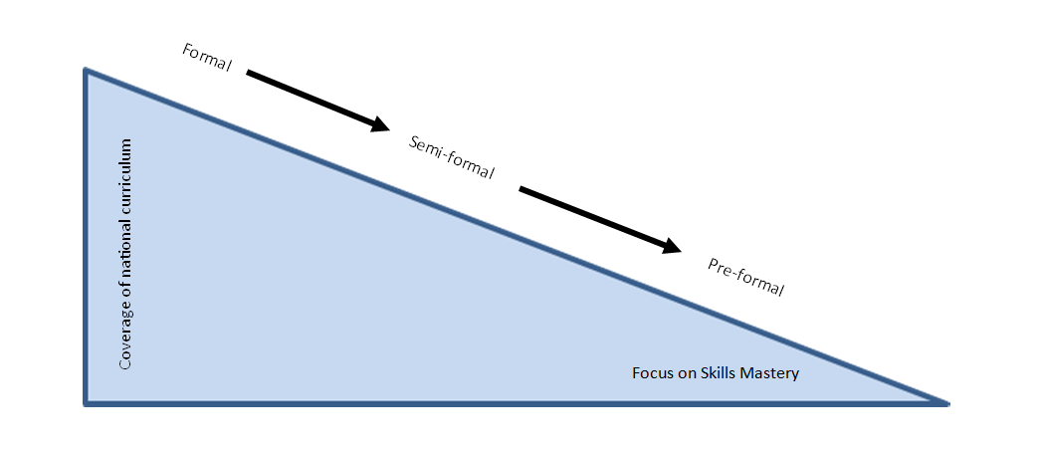

Pre-formal
Our Personalised Learning Intention’s (PLI’s) are a person-centred plan for each child on this pathway. They focus on an individual’s needs, rather than focussing on a set subject-based curriculum. They have been developed for children who are working below the National Curriculum, and for whom will not make progress in a neuro-typical way. The Personalised Learning Intention’s identify appropriate learning approaches for children with severe and profound learning difficulties.
Each PLI is centred on what the child needs, whilst having high levels of ambition as to what they can achieve. Teachers are able to focus on skills which will have the greatest impact on the child’s life, allowing achievable progress for all. The PLI is created by the team working with the child, and are assessed and reviewed regularly.
The pre-formal pathway focusses primarily on four of our curriculum areas:
- My Communication, Language and Literacy
- My Thinking and Learning
- My Independence - Personal, social and mental health
- My Sensory and Physical Well-being.
These areas link directly to the child’s EHCP and set the targets which will support the achievement of their outcomes. Each target is assessed using a 5-point scale (not yet emerging, emerging, developing, secure, mastery). Our assessment recognises progression and development of the same skill, or set of skills, rather than the constant acquisition of new skills. It recognises the learning of skills which are harder to evidence, such as taking turns and showing consideration for others through The Engagement Model. Experiences are planned through our two other areas of learning – Creativity and our Wider World.
Semi-Formal Pathway
The semi-formal pathway is a bridge between the pre-formal and formal pathways where the pupils are ready to access some subject specific curriculum areas. It allows children to begin accessing certain areas of the National Curriculum, whilst also keeping a strong focus on their EHCP outcomes. They may have specific elements of Curriculum built into their target setting, or may access a minimised subject specific framework, focussed usually on the core subjects of Phonics and Early Reading, PSHE and Numeracy.
To support EYFS pupils our curriculum is organised into areas that are in line with Development Matters.
- Communication and language and Literacy
- My Independence - Personal, social and emotional development
- Physical and Sensory development
- My Thinking and Learning - Mathematics
- My Community and Wider World - Understanding the world
- Our Creativity - Expressive arts and design
These are developed using the three Characteristics of Effective Learning: ‘playing and exploring’, ‘active learning’ and ‘creating and thinking critically’.
Formal Pathway
The formal pathway focuses on providing a breadth of subject specific study whilst still allowing the EHCP targets to be central to the pupil’s progression and development. This thematic approach supported by our own bespoke progression documents:
- promotes the spiritual, moral, cultural, mental and physical development of pupils, and
- prepares pupils at our school for the opportunities, responsibilities and experiences of later life.
It is organised into the same six areas as the other pathways, taking in further disciplinary skills to prepare the pupils for further learning and the wider world:

- My Communication and Language and Literacy
- My Independence - Personal, social and emotional development and Food Technology
- My Physical and Sensory Wellbeing – PE and Sensory Awareness
- My Thinking and Learning – Mathematics, Science and Computing
- My Community and Wider World – History, Geography, Forest Schools, Scouts, Religious Education.
- Our Creativity – Art and Music
When a child begins on this pathway, to enable the teacher to set achievable, appropriate targets, there will be a period of baseline assessment, also taking into consideration information from previous placements, other professionals and family.
As children are following a formal learning pathway, they will be working towards National
Curriculum standards as part of our Oakfield Progression documents for each area of learning, but with targets set to their ability informed by EHCPs where appropriate. The expected rate of progress is individualised, considering their needs and abilities.
Curriculum Impact
All pathways are assessed using a summary of progress for each learning intention identified in line with their EHCP targets. Evidence is gathered through Evidence for Learning and can be gathered by all members of staff working with that child. The teacher will review the evidence to make a judgement on progress and provide advice for next steps.
Progress on every pathway will look different for each individual child. The focus is on making, and maintaining, progress with their skills and abilities.
All pathways are assessed by teachers, against our own progression documents, as well as against their own EHCP targets. Teachers are expected to evidence how and when a child meets a target, for all subjects taught to that child. They should make regular and ongoing judgements about progress and identify next steps and areas for development. Pupils record work in books as appropriate to their stage of development.
Additional Learning
The formally delivered curriculum is supported and enhanced by other sessions that are planned for enrichment. These include celebrations of festivals and special dates throughout the year as well as Forest Schools, Scouts, SMSC and ecological activities. These aim to broaden our children’s experiences, whilst also providing an opportunity to apply their skills in different situations.


Document Name: Curriculum
Document Type:Policy
Policy Owner: Headteacher
Date First Issued: September 2023

Version Number: 2.3
Last Review Date: September 2024
Next Review Date: Annually
Signed: 

We are part of the Outcomes First Group Family, by working
together we will build incredible futures by empowering
vulnerable children, young people and adults in the UK to be
happy and make their way in the world.

